**Search Engine**

horizontal line

# 

# What is a search engine?

A search engine is a web-based tool that enables users to locate information on the World Wide Web. Popular examples of search engines are Google, Yahoo!, and MSN Search. Search engines utilize automated software applications that travel along the Web, following links from page to page, site to site. The information gathered by the spiders is used to create a searchable index of the Web.

# How Do Search Engines Work?

Search engines are an integral part of our daily lives. Most of us are familiar with **‘Google’**. How to bake a cake? Where does my favorite actor live? Who wrote this book? What are the latest trends in fashion? And more questions are answered by our friendly ‘Google’.  
Google is one of the many search engines available today which ‘dig’ around the Internet, and present us with the most relevant and valuable information.

Let us now understand, **how do these search engines work?**

Basically all search engines go through **three stages**:

* Crawling
* Indexing
* Ranking and Retrieval

**Crawling**This stage involves scanning the sites and obtaining information about everything that is contained there: page title, keywords, layout, pages that it links to – at a bare minimum.

This task is performed by special software robots, called **“spiders”** or **“crawlers”**.

These robots usually start with the most heavily used servers and popular web pages. The link structure is very important to determine the route that these “crawlers” follow. The new links are followed next to find many interconnected documents, also revisiting the previous sites to check for newly made changes. A never-ending process.

Sometimes the “crawlers” give up, if the actual content is hidden many clicks away from the homepage.

**Indexing**Once all the data has been assimilated, selected pieces of it are stored in huge storage facilities. We can relate in this way: we possess several number of books. Going through all of it is the **crawling**, and making a list of them, along with their authors and other related information is the **indexing**.

This example provides a small-scale view.

If we expand this assumption to books contained in all the libraries in this world, that pretty much explains the magnitude a search engine undertakes.

**Ranking and Retrieval**Search engines are answer machines. Whenever we perform an online search, the search engines scour its database for the most relevant results. Also, it ranks these results based on the popularity of the websites. **Relevance** and **popularity** are the most important factors to be considered by these search engines to provide satisfactory performance.

**Ranking algorithms** differ for different search engines. An engine might assign a weight to each entry, relative to their appearance in the title, meta tags or the sub-headings.

The most basic algorithm uses the frequency of the keyword being searched. This, however, led to something called **“keyword stuffing”**, where the pages are mostly filled with nonsense as long as it includes the keyword.

**3. Explain web crawling? What’s a crawler?**

A web crawler, or spider, is a type of bot that’s typically operated by search engines like Google and Bing. Their purpose is to index the content of websites all across the Internet so that those websites can appear in search engine results.

**4. What is meant by “cached” while searching?**

**If the website is no longer available**Even if a website is no longer available, Google will have a copy stored in its archives. You can still access the cached page.

**If the website has changed dramatically**If a site is no longer related to your search or has hard-to-find information after major changes, viewing the cached page will make you more likely to find relevant and familiar content.

**If you want to view a page faster**Although a cached page may not have the most up-to-date information, it will likely appear more quickly; [page caching can lower server load by up to 80%](http://seositecheckup.com/articles/how-page-caching-optimizes-your-site-performance).

**If you want to optimize for SEO**

Cached websites can be [useful for SEO purposes](http://www.mheroes.com/seo-and-google-cache-do-you-know-the-importance-of-this/): viewing the text-only version of a website will allow you to see it the way Google does when it crawls, giving you a better idea of how to optimize content for keywords and other non-design elements

**5. What's an organic result ?**

Organic search engine optimization (SEO) is the process of showing up higher on the search engine results pages (SERPs) naturally.

Organic search is one of the most effective channels to gain traffic or conversions because it’s free – relative to paid search, where you have to pay for your placement and clicks – and users understand that you are relevant for what they typed in.

A very lame joke in the SEO industry goes, “The best place to hide a dead body is on page two of Google because no one is going to look there.”

See?

Pretty lame, but the point is that if you are not on the first page of SERPs, no one is going to see your pages.

Think about the last time you went to page two of Google to do anything like read an article or buy a product. It doesn’t matter what you were trying to do; there’s almost no way you went to page two to do it.

We can utilize many strategies for organic search, such as [keyword research](https://www.searchenginejournal.com/keyword-research/) and optimizing content or [fixing technical issues](https://www.searchenginejournal.com/how-to-catch-fix-seo-issues/382374/) that hinder a user from accessing the website.

**6. What's a paid result?**

When you type something into Google, you are presented with a list of results; or SERP (the search engine results page) which shows organic results and paid results.

Paid search results have a little green box with the word “Ad” before the listing; this is where a company, like yours, has paid to have their page show up at the top of the list. This can be done through Google Ads search campaign, which charges you a small amount of money for every person who clicks on that link. Paid search works to drive traffic to your website through relevant ads.

**7.** **What is meant by “bounce rate”?**

Bounce Rate is defined as the percentage of visitors that leave a webpage without taking an action, such as clicking on a link, filling out a form, or making a purchase.



Bounce Rate is important for three main reasons:

1. Someone that bounces from your site (obviously) didn’t convert. So when you stop a visitor from bouncing, you can also increase your conversion rate.
2. Bounce Rate may be used as [a Google Ranking factor](https://backlinko.com/google-ranking-factors). In fact, [one industry study](https://backlinko.com/search-engine-ranking) found that Bounce Rate was closely correlated to first page Google rankings.  
   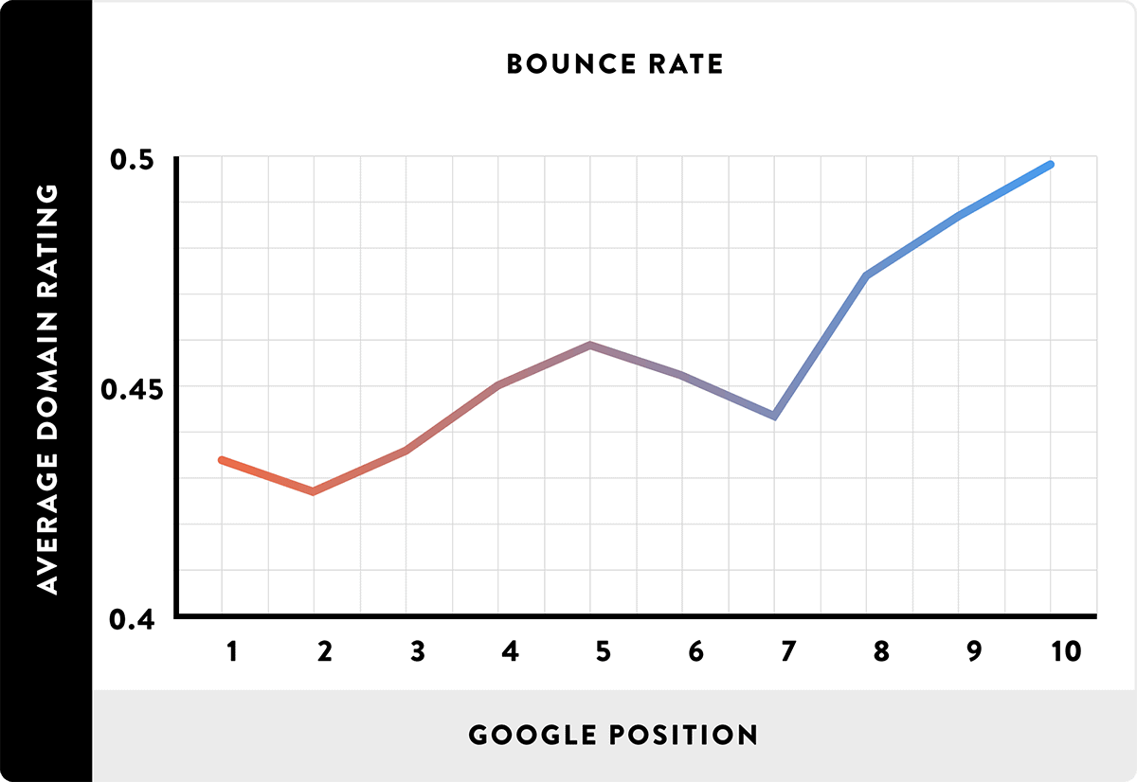
3. A high Bounce Rate lets you know that your site (or specific pages on your site) has issues with content, user experience, page layout or [copywriting](https://backlinko.com/copywriting-guide).

**8. What makes a website appear higher up in search results ?**

### 

1.   
     
     
    1  
    **Make sure that your site is published.**[[1]](https://www.wikihow.com/Get-Your-Website-to-Show-up-on-the-Search-Engines#_note-1)This may sound obvious, but if you're noticing that your website isn't even accessible through traditional search engines such as Google and Bing, you may have missed the final step in publishing your website. Visit your website's hosting site, go to the dashboard, and make sure you've clicked the **Publish** button before proceeding.
2. 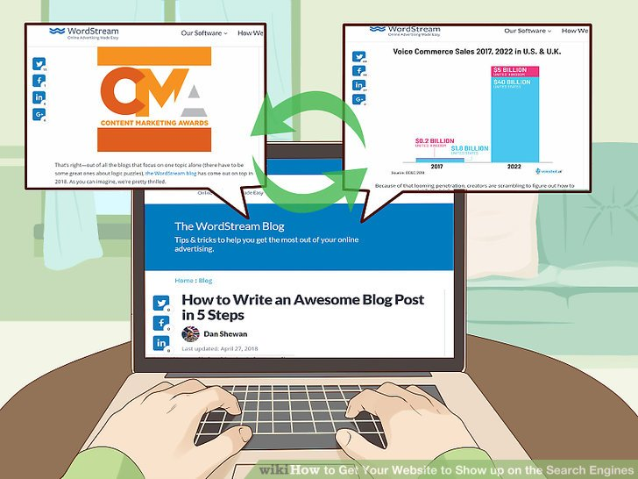  
     
     
    2  
    **Change your home page's content regularly.** Search engines are more likely to place websites which have dynamic (changing) content near the top of search results than they are to use sites that haven't recently updated.
   * You don't need to redo your entire website, but changing the items or graphics displayed on the home page (even just a few times per year) can make a difference in your website's ranking.[[2]](https://www.wikihow.com/Get-Your-Website-to-Show-up-on-the-Search-Engines#_note-2)
3.  3  
    **Add images to your website's pages.** Google, Bing, and Yahoo tend to prioritize webpages which contain images over webpages which don't; similarly, having an image on each webpage means that your website's various pages can show up in Google Images (and their counterparts).[[3]](https://www.wikihow.com/Get-Your-Website-to-Show-up-on-the-Search-Engines#_note-3)
   * Images can eventually slow down your website's pages, so use discretion.
4.   
     
     
    4  
    **Ensure that each page on your website has a description.** Descriptions serve dual purposes: they help improve your website's ranking in search engines, and they help users determine which page link to use before selecting one. This both ensures more people will see your site and cuts down on user frustration.
   * You can usually edit page descriptions on your website host's dashboard.
5. 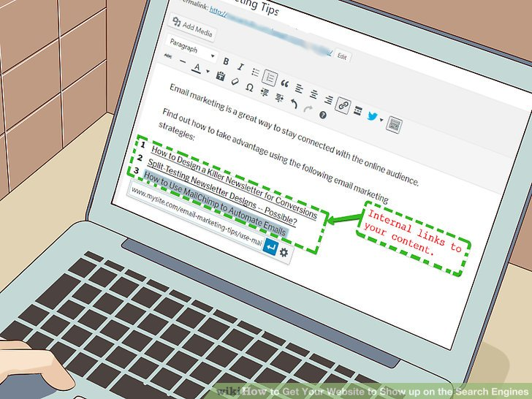  
     
     
    5  
    **Add internal links to your content.**[[4]](https://www.wikihow.com/Get-Your-Website-to-Show-up-on-the-Search-Engines#_note-4)Linking from your home page to every other page on your website is a given, but linking back to your home page (as well as to other related pages) from other pages on your site can increase your site's ranking.[[5]](https://www.wikihow.com/Get-Your-Website-to-Show-up-on-the-Search-Engines#_note-5)
   * The more links your website has, the more pages search engines will be able to index for you.
6.   
     
     
    6  
    **Check your site's mobile version.** While not crucial for search engine ranking, having a mobile version of your site will help increase your site traffic which, in turn, will increase your site's ranking.
   * Most web hosting services provide a mobile version of your site by default. You can edit further this version of your site in order to make it more exclusive to mobile users.
7.   
     
     
    7  
    **Maintain a weekly blog.** Every website should have a blog page on which you post a new piece at least once per week. This keeps your website "active" in the eyes of search engines.[[6]](https://www.wikihow.com/Get-Your-Website-to-Show-up-on-the-Search-Engines#_note-6)
   * When writing blog pieces, make sure you use keywords that fit your website's theme. For example, if you run a website for hiking enthusiasts, make sure to use words like "hiking" and "outdoors" in addition to terminology about specific hiking locations or equipment.[[7]](https://www.wikihow.com/Get-Your-Website-to-Show-up-on-the-Search-Engines#_note-7)
   * Blog pieces should be around 300 words long.
   * You can always hire a guest writer to create your blog pieces if you don't have the time to create them.
8.   
     
     
    8  
    **Promote your website using content aggregators.** "Content aggregators" are websites, services, or social media on which large numbers of people can see, react to, and share content; naturally, sharing your website in such a location will boost your site traffic, thus increasing your search engine rating. A great starting point is through the help of press releases because they help you get. published on hundreds of news sites, optimising SEO, building backlinks, and help you rank on Google. Common content aggregators include the following:[[8]](https://www.wikihow.com/Get-Your-Website-to-Show-up-on-the-Search-Engines#_note-8)
   * Reddit
   * Twitter
   * Facebook
   * Instagram
   * Medium
   * WordPress
   * StumbleUpon
9.   
     
     
    9  
    **Encourage others to link to your website.** Each "inbound" link—that is, a link that directs people toward your website—increases your search engine ranking, so having sources such as other websites linking to your website will improve your search ratings.[[9]](https://www.wikihow.com/Get-Your-Website-to-Show-up-on-the-Search-Engines#_note-9)
   * You can also place links to your website in places like social media bios and your LinkedIn profile.

**9. How do your past search activity affect your search results ?**

When you search on Google, your past searches and other info are sometimes incorporated to help us give you a more useful experience.

For example, if you search for chocolate cake, and then search again for “how to make,” Google might be more likely to predict that you’re searching for “how to make chocolate frosting.” These predictions are based on your past searches to give you better results and help you pick up where you left off.



You can also get personalized recommendations for events, movies and shows to watch, web pages in your Discover feed and more. Depending on your [Activity Controls](https://myactivity.google.com/activitycontrols?utm_source=help&utm_medium=websearch), these recommendations are based on activity saved to your Google Account such as:

* Your Search history on Google
* Results or ads from Search that you click
* Discover content you like or dislike

**10. Are there any search engines that don't track your activity ?**

Yandex